CIS 5400: Mobile Application Programming

Project 2

By: Bernice Templeman

10/18/2015

Btempleman2015@my.fit.edu

**Project 2 Instructions:**

Add to the program created for the midterm and include saved data.

Your program should save something to the mobile device and use it for preferences, loading data from the previous session, etc.

Upload a word document with

* an explanation of what you are saving and
* how it is being used
* along with screen shots of the program saving and loading the file.

**MidTerm Instructions:**

Write a small mobile application using at least 2 of the mobile functions we've studied so far.

Your app should include a paragraph about:

* what it does,
* what interface libraries you are using (JQuery Mobile, etc),

and the code. Include screen shots of the program working and paste it into the word document.

**Project 2**

I added a front page to the Cardio Tracker Application that allows the user to add and delete workouts.

This data is saved so if the application is closed then re-opened, the workouts are still there.

By default, the application initializes the database with 2 example workouts which can be deleted.

This database provides a quick way to enter a workout and view all your workouts.

My Application is a Cordova and JQuery Mobile App with:

* Cordova Events
* Cordova Camera
* Cordova console
* Cordova dialogs
* jQuery Mobile header
* jQuery Mobile footer
* jQuery Mobile list
* jQuery Mobile text box (dialog box),
* jQuery Mobile buttons
* jQuery Mobile form

I included these libraries:

* <link rel="stylesheet" href="http://code.jquery.com/mobile/1.2.0/jquery.mobile-1.2.0.min.css" />
* <link rel="stylesheet" href="shareqr3.3.css" />
* <script src="http://code.jquery.com/jquery-1.7.2.min.js"></script>
* <script src="http://code.jquery.com/mobile/1.2.0/jquery.mobile-1.2.0.min.js"></script>
* <script src="shareqr3.3.js"></script>
* <script type="text/javascript" charset="utf-8" src="cordova.js"></script>

Cordova first gives a message to let the user know the app is read (deviceready).

The first page allows the user to vie their workouts.

They can add new workouts or delete workouts.

The user can then select “Photos” to go to a list of days they want to add a photo or enter their stats.

They also have the ability to search the list for the day.

When they select the day, they are presented with a page for the day.

On the day page, they have the option to select a photo to see their stats.

They can then enter:

* A note (text)
* Time (integer)
* Calories (integer)
* Distance (integer)

There is a button to Submit/Save their results.

Saving data is currently not enabled on this page.

**Future Enhancements:**

* Learn JavaScript
* Saving stats data to a file that can be reloaded/ updated.
* Displaying the total Cardio minutes/week.
* Displaying the total Distance/week.

**Resources Used:**

* Book examples: Apache Cordova API Cookbook by John M Wargo
* <https://ctoinsights.wordpress.com/2012/01/03/jquery-mobile-tutorial-part-iii-managing-data/>
* <http://www.w3schools.com/jquerymobile/jquerymobile_filters.asp>
* <https://demos.jquerymobile.com/1.2.0/docs/toolbars/docs-navbar.html>
* <http://www.jefflinwood.com/2011/07/building-a-jquery-mobile-html5-app-with-phonegap-for-drupal-7-part-2/>
* <http://iviewsource.com/codingtutorials/5-minute-guide-to-a-mobile-app-with-jquery-mobile/>
* <http://www.ripperdesignandmultimedia.com/2012/09/06/jquery-mobile-use-phone-camera-using-cordova-2-0/>
* <http://www.gajotres.net/building-a-native-mobile-app-with-cordova-and-jquery-mobile/2/>
* <http://www.codeproject.com/Articles/896792/Uploading-Displaying-Images-in-a-JQuery-Mobile-App>
* <http://www.sitepoint.com/build-a-currency-converter-with-jquery-mobile-and-cordova-rate-updates/>
* <http://www.raymondcamden.com/2013/07/23/better-example-of-phonegap-parse-and-uploading-files>
* <http://samcroft.co.uk/2013/using-localstorage-to-store-json/>

Program loads 2 initial default workouts. These can be deleted and new ones can be added.

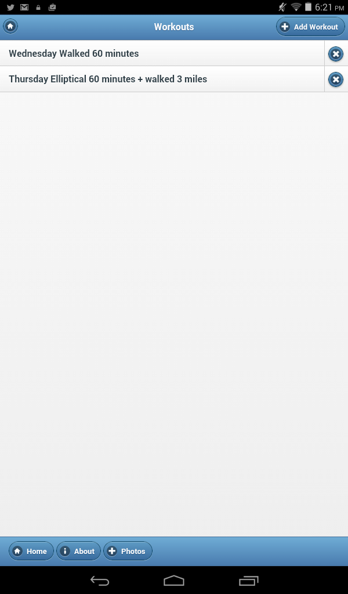

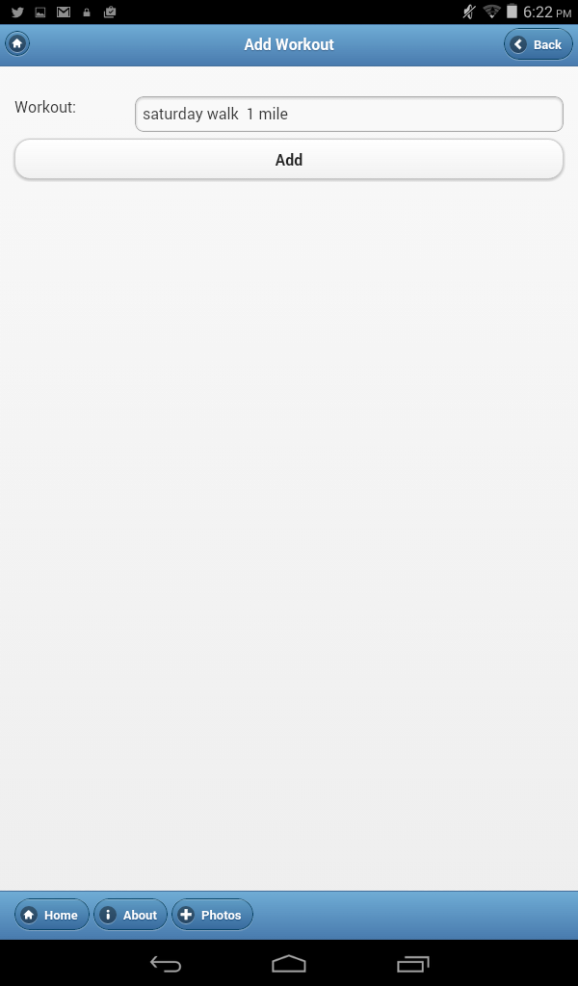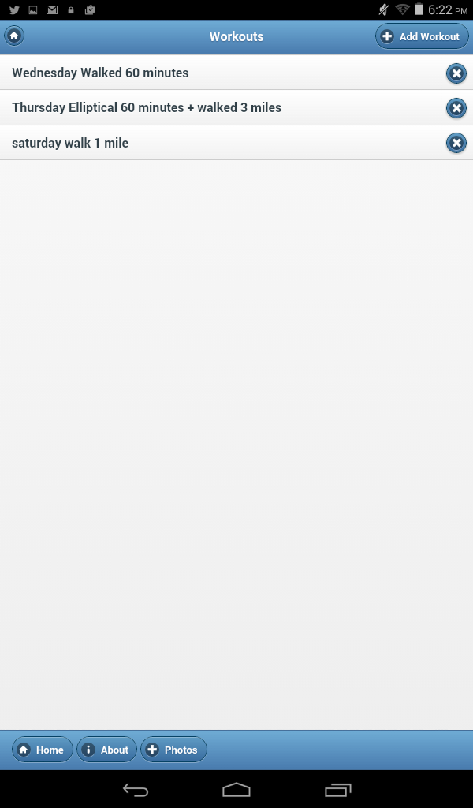

**After closing & reopening the App, the workouts are still there:**

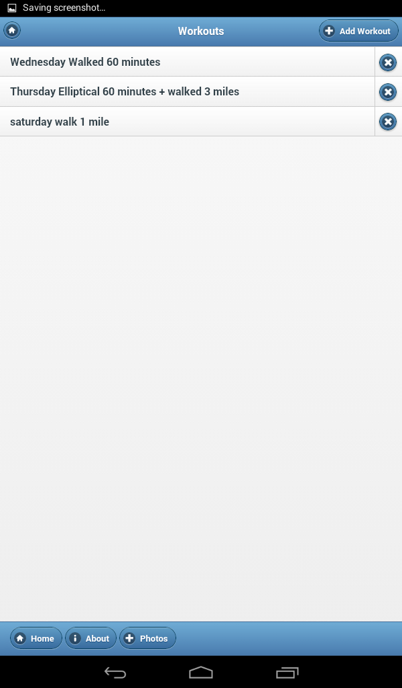

**Workout can be deleted:**

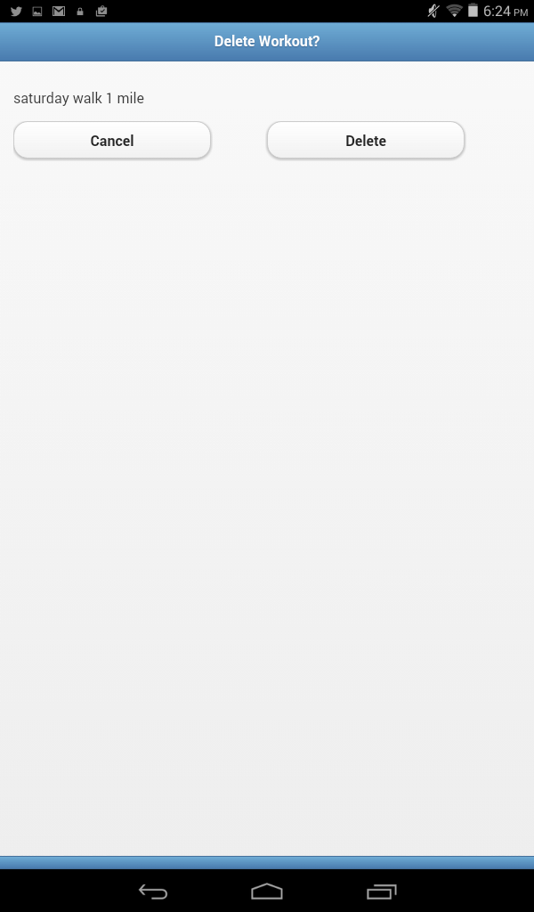

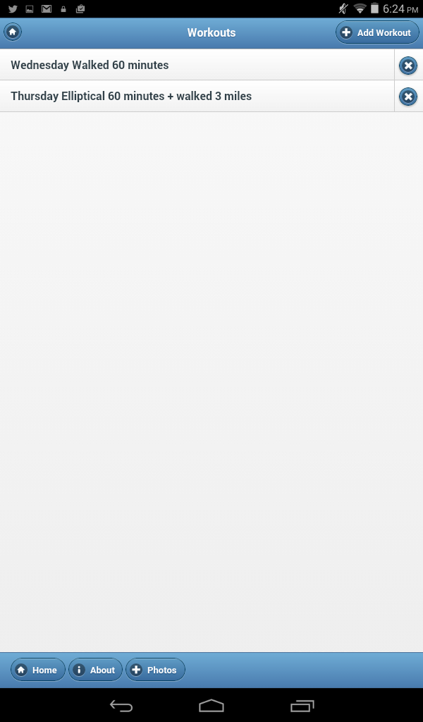

**There is an About Screen:** 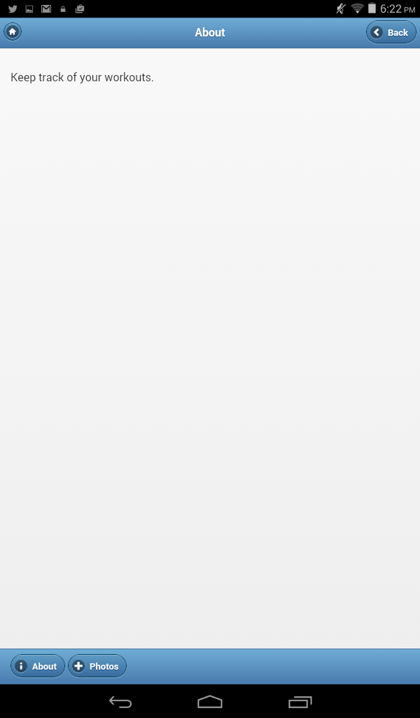

**The “Photos” button allows you to go to a daily menu where you can select the day**

**and then select a photo**

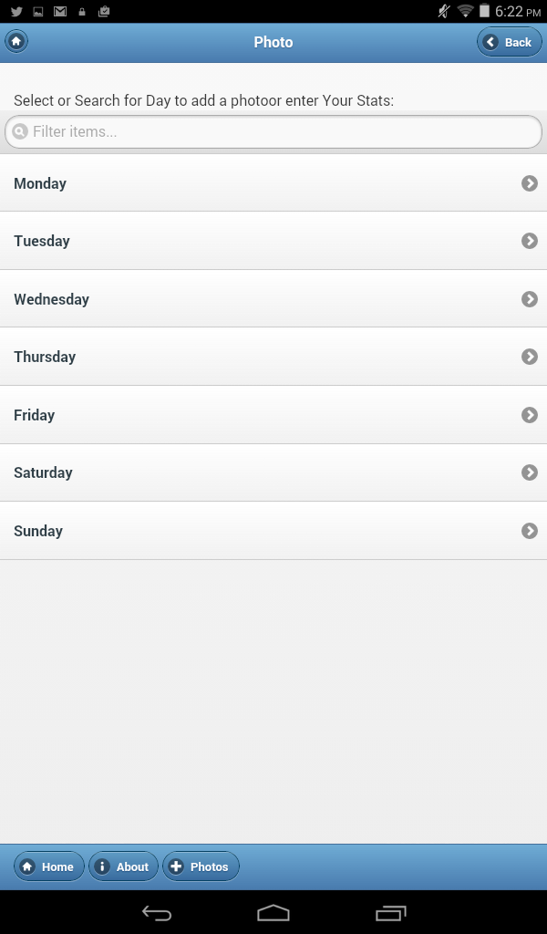

**This data is currently not being saved in the application.** 